module: "1" lesson: "9" step_number: "1" step_title: "Material and Colour Introduction" template_type: "article" target_learner: "# HNC Interior Design Foundation Learner Profile

* **Has:**  Basic math, English proficiency (B2), computer fundamentals
* **Needs:**  Technical drawing, space planning, CAD software, professional communication, project workflow management

generation_date: "2025-04-04 12:17:55" ---

# Material Properties and Colour Theory in Interior Design

As a designer, your choices of materials and colours communicate volumes. These tangible elements transform abstract concepts into physical spaces that people experience with all their senses. This knowledge directly complements your presentation techniques and forms a crucial foundation for your upcoming project planning work.

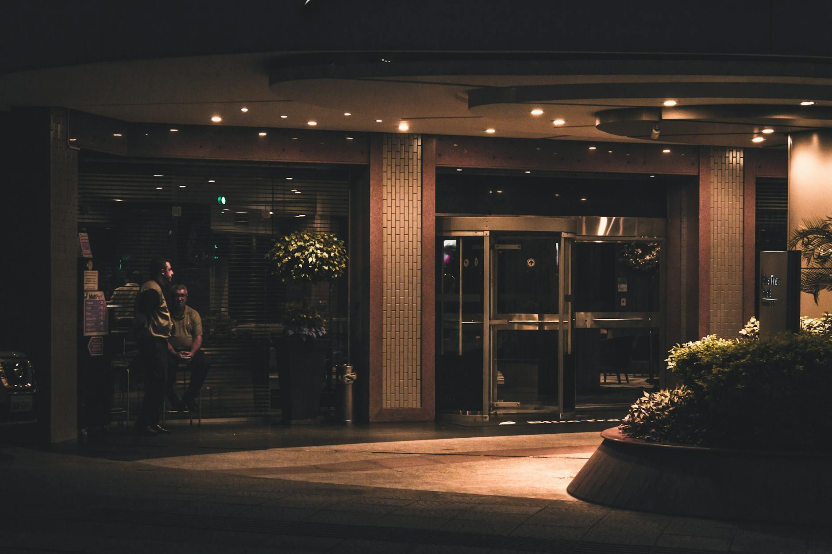

Fig.1 (Gustavo Rodrigues on [Pexels](https://www.pexels.com/photo/1755288/), 2025) The thoughtful combination of materials and colours creates a space that engages multiple senses while maintaining visual harmony.

## 1. Understanding Material Properties

### Material Categories and Applications

Interior materials typically fall into several key categories:

* **Hard surfaces**: Wood, stone, tile, metals
* **Soft goods**: Textiles, carpets, upholstery
* **Manufactured products**: Laminates, composites, vinyl
* **Finishes**: Paints, stains, varnishes
* **Flexible surfaces**: Rubber, linoleum, cork
* **Sustainable options**: Bamboo, recycled glass, reclaimed materials

Each material family possesses unique characteristics making it appropriate for specific applications. For instance:

| Material | Practical Benefits | Potential Limitations | |----------|-------------------|------------------------| | Hardwood flooring | Warmth, natural beauty, durability | Susceptible to moisture damage, requires maintenance | | Porcelain tile | Water-resistant, durable, easy to clean | Cold underfoot, hard surface, can be slippery | | Wool carpet | Sound absorption, comfort, insulation | Maintenance challenges, potential allergen concerns |

**Try this when exploring materials:** Start a "material journal" with samples or photos of interesting materials you come across. For each entry, jot down:

* Visual appearance (colour, pattern, texture)
* Tactile qualities (temperature, texture)
* Common applications and rationale
* One unexpected use you might imagine for it

This journal will become a valuable resource as you tackle future design projects.

### The Sensory Experience of Materials

Materials speak to us through multiple senses:

* **Visual qualities**: How does light interact with the surface? Is it reflective or matte?
* **Tactile qualities**: How does it feel to touch? Smooth, rough, warm, cool?
* **Acoustic properties**: Does it absorb or reflect sound?
* **Olfactory aspects**: Does it have a distinctive smell? (Think of leather or cedar)
* **Maintenance requirements**: How easily can it be cleaned or repaired?



Fig.2 (Photo By: Kaboompics.com on [Pexels](https://www.pexels.com/photo/8901290/), 2025) Exploring material textures is crucial for understanding how spaces will feel to users - the tactile experience matters just as much as visual appeal.

**Try this sensory exploration:** Close your eyes and touch three different surfaces nearby. How does each make you feel? What associations spring to mind? Think about how these emotional responses might influence your material selections for different spaces.

### Performance Considerations

When picking materials for a design project, weigh these practical factors:

1. **Durability**: Will the material stand up to its intended use?
2. **Maintenance**: What cleaning routines are needed?
3. **Safety**: Does it meet fire codes and slip resistance requirements?
4. **Sustainability**: What's its environmental footprint?
5. **Budget**: Does it fit within the project's financial constraints?
6. **Availability**: Can you source it within your timeline?

Remember: Even the most stunning material is inappropriate if it fails in context. Marble flooring might look spectacular in a luxury hotel lobby but would be a poor choice for a children's playroom.

## 2. Colour Theory Foundations

### The Colour Wheel and Basic Relationships

The colour wheel serves as a fundamental tool for understanding colour relationships:

From this foundation, we develop colour schemes:

* **Monochromatic**: Variations of a single colour (light blue, medium blue, dark blue)
* **Analogous**: Colours adjacent on the wheel (blue, blue-green, green)
* **Complementary**: Colours opposite on the wheel (blue and orange)
* **Triadic**: Three colours equidistant on the wheel (red, yellow, blue)
* **Split-complementary**: A base colour plus two colours adjacent to its complement

**Question you might be wondering:** How do I decide which colour scheme suits a particular project?

It really depends on the desired mood and function of the space. Monochromatic schemes bring harmony and sophistication; complementary schemes offer energy and visual interest; analogous schemes provide cohesion while giving more variety than monochromatic approaches.

### The Psychology of Colour

Colours trigger emotional and psychological responses:

* **Red**: Energy, passion, appetite stimulation
* **Blue**: Calm, trust, concentration
* **Yellow**: Optimism, clarity, attention-grabbing
* **Green**: Nature, growth, relaxation
* **Purple**: Luxury, creativity, sophistication
* **White**: Cleanliness, simplicity, spaciousness
* **Black**: Sophistication, drama, formality

**Important Note:** These associations aren't universal—they're shaped by cultural context, personal experience, and specific applications. Always consider your client's cultural background and personal preferences.

**Try this colour analysis:** Pick a room in your home you'd like to improve. What feelings do you want to evoke in this space? Identify three colours that might help achieve this emotional response. How might these colours work together? Consider testing small samples before committing to a full scheme.

## 3. Material and Colour Combinations

### Creating Cohesive Palettes

Materials and colours work in tandem to create cohesive environments:

1. **Start with a foundation material** (often flooring or a major architectural element)
2. **Build a colour palette** that complements this foundation
3. **Add secondary materials** that enhance the palette
4. **Include accent materials/colours** for visual interest
5. **Consider the transitions** between different materials and spaces

**Common Mistake to Avoid:** Selecting materials and colours in isolation rather than considering how they interact together in a space.

### Material and Colour Boards

Material boards help visualise how materials and colours will work together:

1. Arrange material samples in proportion to their use in the space
2. Include colour swatches for painted surfaces
3. Label all samples clearly
4. Organise samples to show relationships
5. Consider lighting conditions – natural and artificial

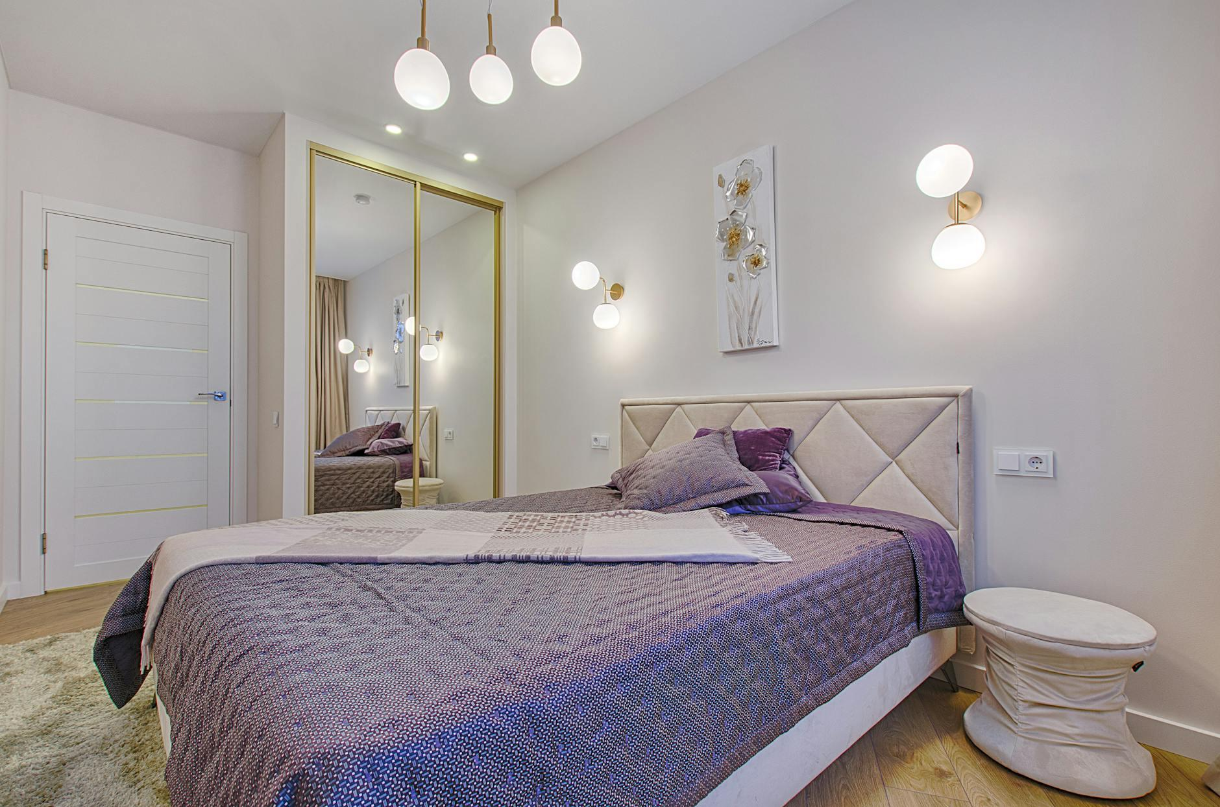

Fig.3 (Vecislavas Popa on [Pexels](https://www.pexels.com/photo/1743231/), 2025) A well-executed material board communicates design intent clearly and helps clients visualize how different elements will work together in the finished space.

**Try this visualization technique:** For your next project, create both a physical and digital material board. The physical board lets you experience true textures and colours, while the digital version gives you flexibility for client presentations and revisions. Compare the two experiences – what advantages does each format offer?

## 4. Professional Specification Standards

Knowing how to specify materials professionally is a key skill for your upcoming project work:

### Important Specification Information

For each material in your design, document:

* Exact product name and manufacturer
* Colour/finish/pattern name and number
* Size/dimensions
* Installation method
* Maintenance requirements
* Cost per unit
* Sustainability credentials (when applicable)

### Sample Specification Format

ITEM: Flooring - Living Room  
PRODUCT: Engineered Hardwood Flooring  
MANUFACTURER: [Company Name]  
STYLE/COLLECTION: [Name]  
COLOUR/FINISH: [Name/Number]  
DIMENSIONS: 5" width planks, 3/8" thickness  
INSTALLATION: Floating floor installation  
MAINTENANCE: Sweep regularly, damp mop with manufacturer's recommended cleaner  
COST: £XX per square metre  
SUPPLIER: [Company Name and Contact]

**Try this professional practice:** Create a digital template for material specifications you can use throughout your career. Include all the categories above, plus any others you think might be relevant. Having a consistent format will save you time and showcase your professionalism to clients and contractors.

Remember that material and colour selections go beyond mere aesthetics—they're functional decisions that directly impact how people experience and use spaces. As you develop your design skills, you'll increasingly grasp how these elements can transform environments and influence human behavior.